Odoo Discuss

# What is Discuss?

Odoo Discuss is an easy to use messaging app for teams that brings all your organization's communication into one place and seamlessly integrates with the Odoo platform. Discuss lets you send and receive messages from wherever you are in Odoo as well as manage your messages and notifications easily from within the app. Discuss allows you to create channels for team chats, conversations about projects, meeting coordination, and more in one simple and searchable interface. Think of is as a built in, simplified version of Jabber, Slack or Teams. In fact, if you have ever used Slack, there are a lot of similarities on how it works.

# Enabling Desktop Notifications

Odoo can show desktop notifications when you receive a message, even if you are browsing in other windows.

To enable desktop notifications:

* Open the **Discuss App**.
* On the top of the dashboard, click the link to **enable desktop notifications.**

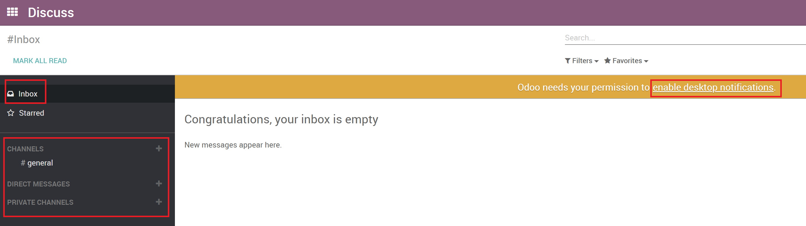

* Click Allow on the browser security notification popup.

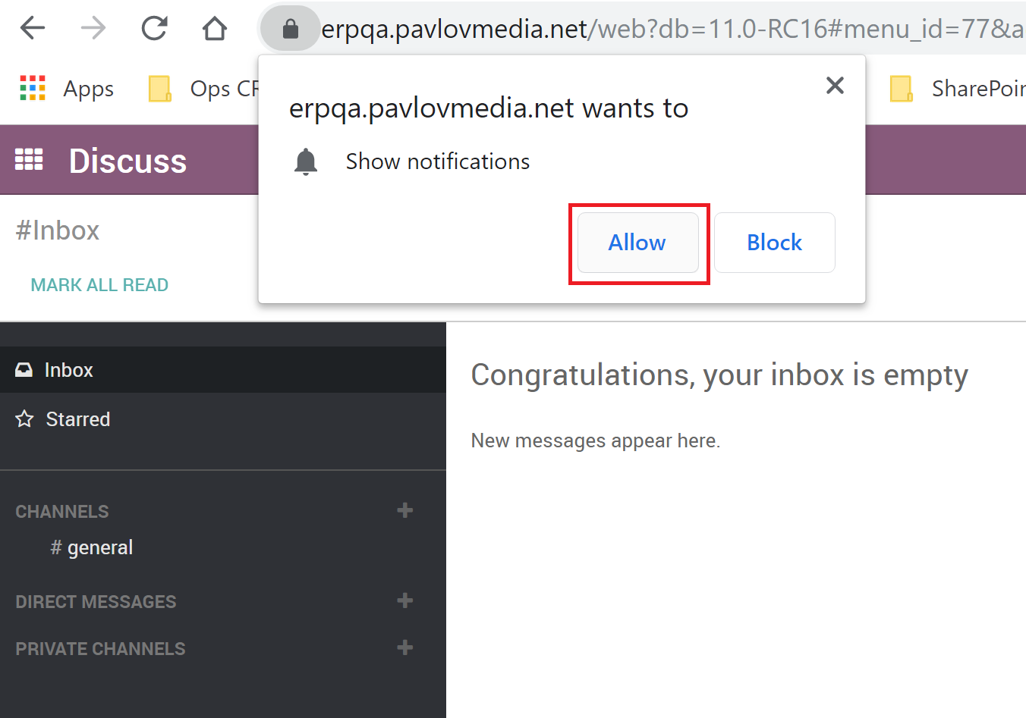

* You will see a confirmation message that permission has been granted and the orange bar will disappear.

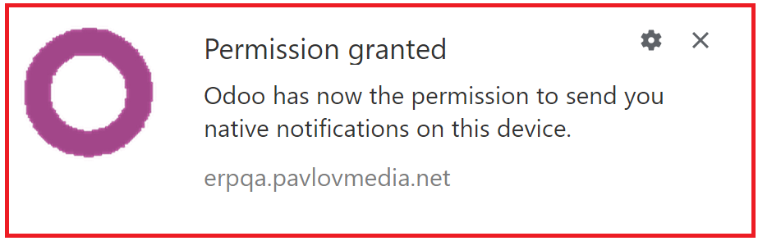

# Using Discuss

You can mention a user in a channel or chatter directly on the record by typing **@user-name**. Mentioning a user in the chatter will set them as a follower of the item (if they are not already) and send a message to their inbox. The item containing the mention will also be bolded in the list view. Mentioning a user in a channel will send a message to their inbox. You cannot mention a user in a channel who is not subscribed to the channel. Typing #channel-name will provide a link to the mentioned channel in either a chatter or another channel.

## Direct messaging a user

Direct messages are private messages viewable only by the sender and recipient. You can send direct messages to other users from within the Discuss module by creating a new conversation or selecting an existing one from the sidebar. Direct messages can be sent from anywhere in Odoo using the speech bubble icon in the top bar. The online status of other users is displayed to the left of their name. A green dot indicates that a user is Online, an orange dot that they are Idle, and a grey dot that they are offline.

## Desktop notifications from Discuss

You can choose to see desktop notifications when you receive a new direct message. The notification shows you the sender and a brief preview of the message contents. These can be configured or disabled by clicking on the gear icon in the corner of the notification.

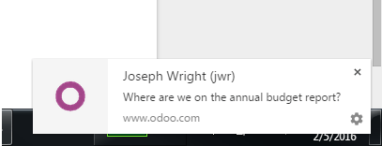

# Channels

You can use channels to organize discussions between individual teams, departments, projects, or any other group that requires regular communication. By having conversations that everyone in the channel can see, it's easy to keep the whole team in the loop with the latest developments.

## Creating a channel

In Discuss there are two types of channels - **public** and **private**.

A public channel can only be created by an administrator with write privileges and can be seen by everyone in the organization. By contrast, a private channel can be created by any user and by default is only visible to users who have been invited to this channel.

**Note**: A public channel is best used when many employees need to access information (such as interdepartmental communication or company announcements), whereas a private channel should be used whenever information should be limited to specific users/employees (such as department specific or sensitive information).

## Configuring a channel

You can configure a channel's name, description, access rights, automatic subscription, and emailing from #channel-name ‣ Settings. Changing channel access rights allows you to control which groups can view each channel. You can make a channel visible by all users, invited users, or users within a selected user group. Note that allowing "Everyone" to follow a private channel will let other users view and join it as they would a public channel.

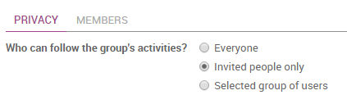

## Locating a channel

If you do not see a channel on your dashboard, you can search the list of public channels to locate the correct channel or create a new channel by clicking the plus icon.

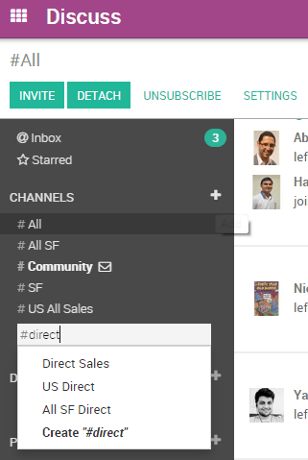

You can also click the CHANNELS heading to browse a list of all public channels. This allows the user to manually join and leave public channels from a single screen.

**Note**: It is always wise to search for a channel before creating a new one to ensure that duplicate entries are not created for the same topic.

## Using filters to navigate within Discuss

The top bar search provides access to the same comprehensive search function present in the rest of Odoo. You can apply multiple filter criteria and save filters for later use. The search function accepts wildcards by using the underscore character "_" to represent a single character wildcard.